Ethan Klukkert

Professor Foss

CS-255

16 October 2022

# CS 255 System Design Document Template

## UML Diagrams

### UML Use Case Diagram

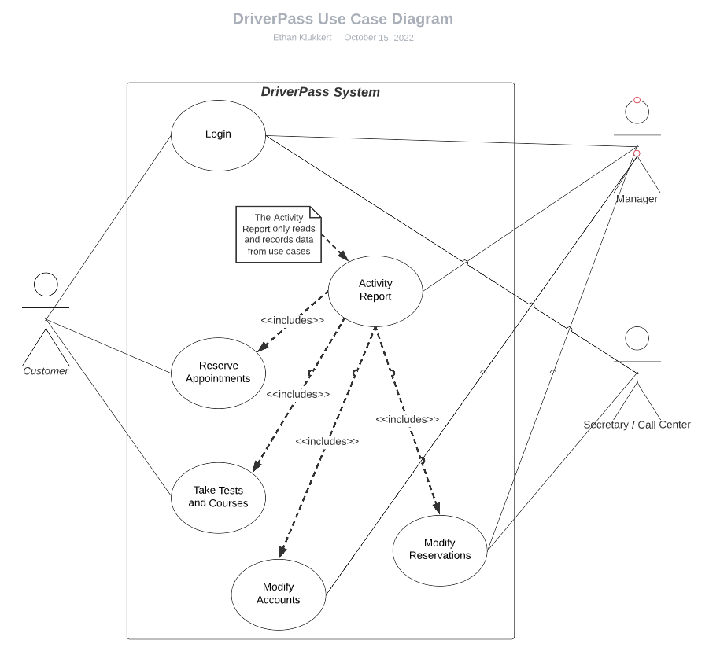

### UML Activity Diagrams

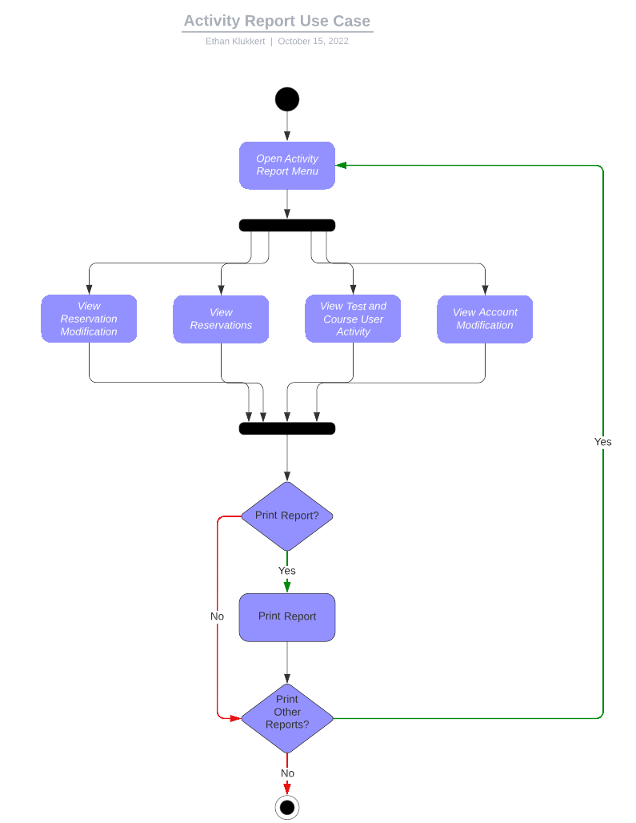

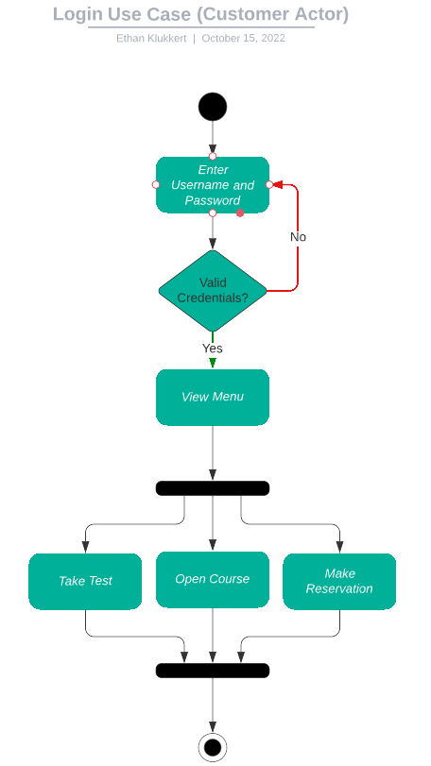

### UML Sequence Diagram

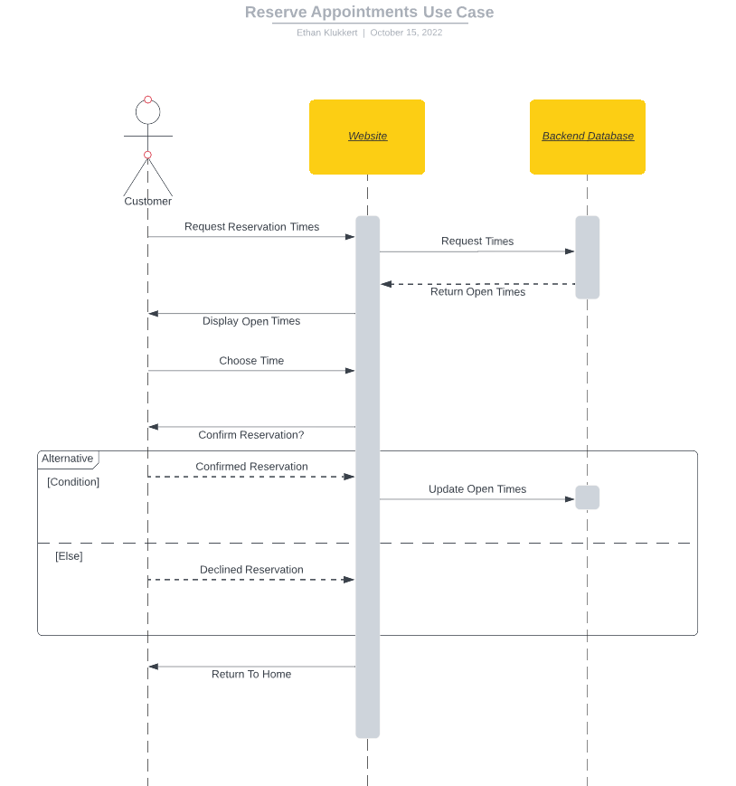

### UML Class Diagram

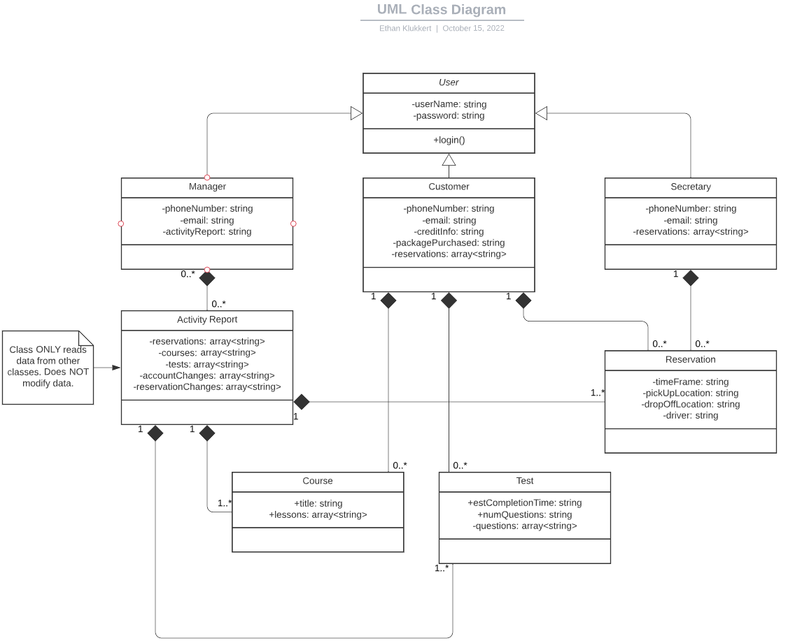

## Technical Requirements

The hardware requirement for this design is limited. The system is web-based, and thus the only requirement for hardware would be the phones needed for the secretaries that assist in reservations over-phone.

The software requirements for the system include the ability for the website to run on all browsers. This would mean that the project would need to be written in JavaScript, which is built-in for almost all web browsers. The software would need to be able to communicate between the users and the servers, as well as communicate with third parties such as the DMV to keep up with regulations. To help with the system performance on the client side, a Single-Page Application design would be preferred over multiple pages, due to the potential slow speed of the user’s/server connection.

The system needs infrastructure that accommodates the backend. The client has stated they wanted a cloud-based infrastructure to run the security and server-side information. This cloud structure would need to be distributed to areas that are expected to use the system in order to avoid system speed issues. The system also needs a call center or remote employee infrastructure to accommodate the secretaries in helping organize reservations for customers.